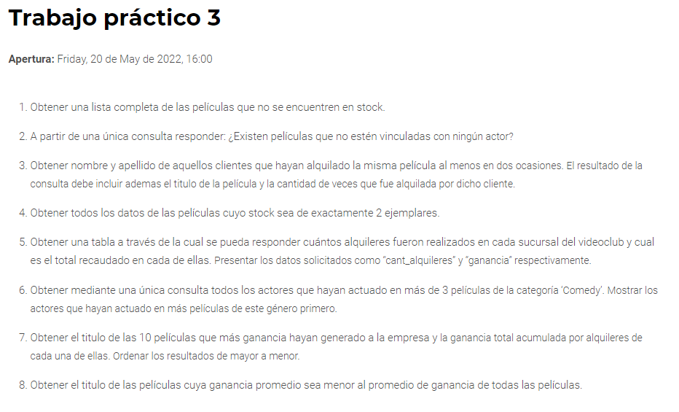

1

SELECT title

FROM film

WHERE film_id NOT IN (SELECT film_id FROM inventory);

2

SELECT title

FROM film

WHERE film_id NOT IN (SELECT film_id FROM film_actor)

3

SELECT first_name, last_name,title , COUNT(film.film_id) as cantidad

FROM customer

INNER JOIN rental ON rental.customer_id = customer.customer_id

INNER JOIN inventory ON inventory.inventory_id = rental.inventory_id

INNER JOIN film ON film.film_id = inventory.film_id

GROUP BY film.film_id

HAVING >= 2

ORDER BY `cantidad`;

4

SELECT *

FROM film

WHERE film_id IN (SELECT film_id

FROM (SELECT film_id, COUNT(*) as cantidad

FROM inventory

GROUP BY film_id

HAVING cantidad = 2) as tabla);

5

SELECT store.store_id, COUNT(*) as cant_alquileres, SUM(payment.amount) as ganancia

FROM store, payment, rental, staff

WHERE store.store_id = staff.store_id AND staff.staff_id = payment.staff_id AND payment.rental_id = rental.rental_id

GROUP BY store.store_id;

6

SELECT actor.actor_id,actor.first_name, actor.last_name , COUNT(*) as cantidad

FROM actor, film_actor, film, film_category, category

WHERE actor.actor_id = film_actor.actor_id AND film_actor.film_id = film.film_id AND film.film_id = film_category.film_id and film_category.category_id = category.category_id AND category.name = "comedy"

GROUP by actor.actor_id

HAVING cantidad > 3

ORDER BY cantidad DESC;

7

SELECT film.film_id, title, SUM(amount) as ganancia

FROM film, inventory, rental, payment

WHERE film.film_id = inventory.film_id AND inventory.inventory_id = rental.inventory_id AND rental.rental_id = payment.rental_id

GROUP by film.film_id

ORDER BY ganancia DESC

LIMIT 10;